Pick-up Instructions:

1. Approach the gate to distribution center parking lot and hit the "will call" button

* Please be ready to provide the name on your order and your order number.

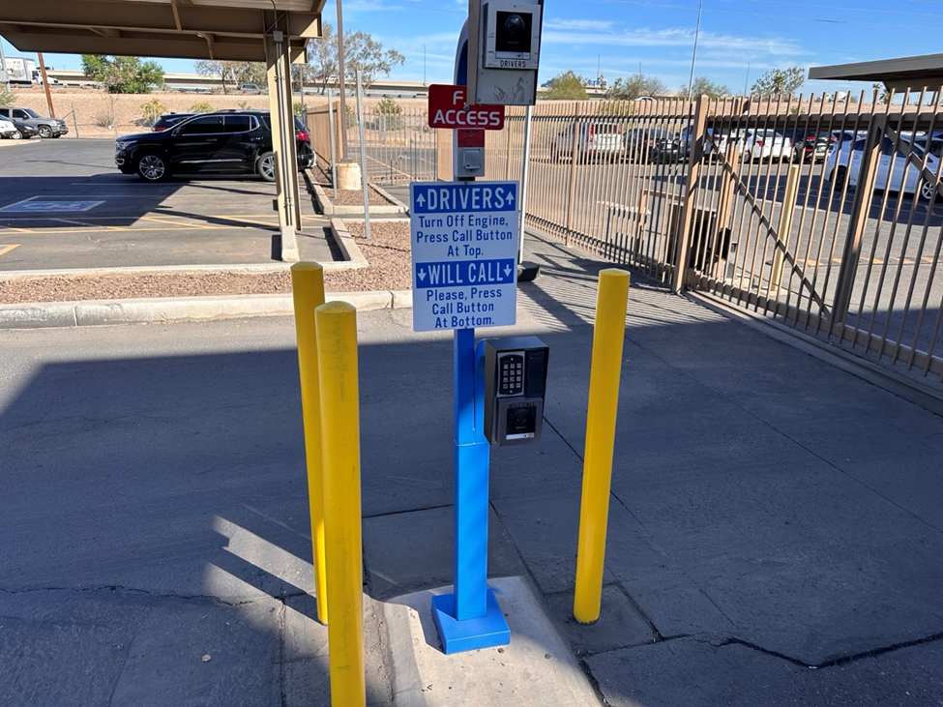

2. Once your details have been verified, the gate will open.

3. Park in the "Will Call" parking spot to the right of the Shipping dock

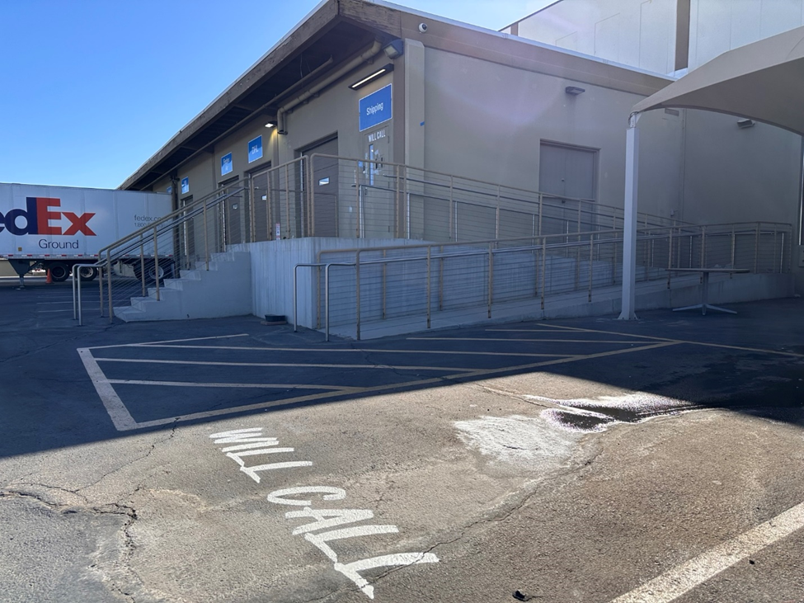

4. A team member will meet with you near the door marked “Will Call” to coordinate.

\*\*For any questions, or to reschedule your pickup, please contact customer service at:  
  
Toll Free: 1-833-393-8007

Phone: +1 602-685-3922

Email: cs@onlinecomponents.com

Hours: Monday – Friday 6:00am - 4:00pm PST (13:00 - 00:00 GMT)